class M1 {

public static int add(int a, int b) {

return a+b;

}

public static void main(String[] arg) {

System.out.println("addition of two integer no = "+add(1,3));

}

}

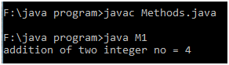

class M2 {

public static double double_add(double x, double y) {

return x + y;

}

public static void main(String[] arg) {

System.out.println("addition of two double no = "+double_add(28.34,6.03));

}

}

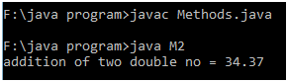

class M3 {

public static double calc_speed(double distance, double time) {

return (distance/time);

}

public static void main(String[] arg) {

System.out.println("Speed = "+ calc_speed(450.5,12.0));

}

}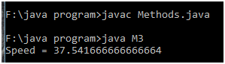

class M4 {

public static float circle(float radius) {

return (3.14f*radius*radius);

}

public static void main(String[] arg) {

System.out.println("Area of Circle = "+ circle(8.5f));

}

}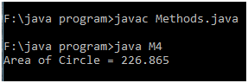

class M5 {

public static int factorial(int n) {

int fact = 1;

for(;n>=1;n--) {

fact *= n;

}

return fact;

}

public static void main(String[] arg) {

System.out.println("factorial value = "+ factorial(7));

}

}

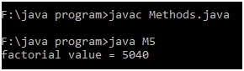

class M6 {

public static boolean even(short n) {

return (n%2==0)?true:false;

}

public static void main(String[] arg) {

//simply an integer no is int type, until it is casted to byte or short

System.out.println("The given no is even? "+ even((short)479));

}

}

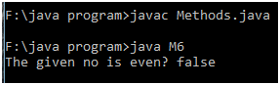

class M7 {

public static boolean odd(short n) {

return (n%2==1)?true:false;

}

public static void main(String[] arg) {

//simply an whole no is integer, until it is casted to byte or short

System.out.println("The given no is odd? "+ odd((short)119));

}

}

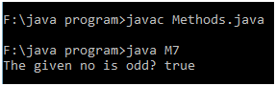

class M8 {

public static boolean prime(short n) {

short i;

for(i=2;i<=n/2;i++)

if(n%i==0)

break;

return (i>n/2)?true:false;

}

public static void main(String[] arg) {

//simply an whole no is integer, until it is casted to byte or short

System.out.println("check no is prime "+ prime((short)17));

}

}

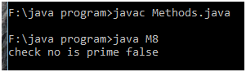

class M9 {

public static boolean palindrome(int n) {

int temp=n, rev=0, rem;

while(temp!=0) {

rem = temp%10;

rev = (rev*10) + rem;

temp /= 10;

}

return (rev == n)?true:false;

}

public static void main(String[] arg) {

System.out.println("check no is palindrome "+ palindrome(5995));

}

}

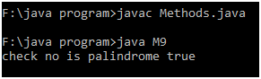

class M10 {

public static boolean div6(short n) {

return (n%6==0)?true:false;

}

public static void main(String[] arg) {

System.out.println("The given no is divisible by 6? "+ div6((short)84));

}

}

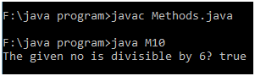

class M11 { //quotient gives hours, remainder gives minutes

public static int time(int n) {

return n/3600;

}

public static void main(String[] arg) {

System.out.println("time in hours = "+ time(21600));

}

}

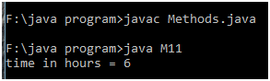

class M12 { //Counting digit don't require remainder

public static int count_digit(int n) {

int digit=0;

do {

n/=10;

digit++;

}while(n!=0);

return digit;

}

public static void main(String[] arg) {

System.out.println("NO of digit in a number = "+ count_digit(0));

}

}

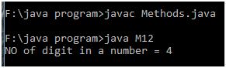

class M13 {

public static int make2Digits(int n) {

int count=0;

while(n!=0) {

n/=10;

count++;

}

n= (n* (int)Math.pow(10,count))+n;

return n;

}

public static void main(String[] arg) {

System.out.println("making of two digits = "+ make2Digits(215));

}

}

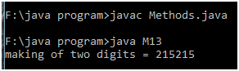

class M14 {

public static int hundsDigit(int n) {

return (n/100)%10;

}

public static void main(String[] arg) {

System.out.println("Hundred's digit of a number = "+ hundsDigit(21));

}

}

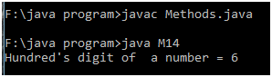

class M15 {

public static float runrateRequired(int target, int maxOver, int currentScore, int oversBowled) {

int remScore, remOvers;

remScore = target - currentScore;

remOvers = maxOver - oversBowled;

return (float)remScore/remOvers;

}

public static void main(String[] arg) {

System.out.println("Required Run Rate = "+ runrateRequired(326,49,210,33));

}

}

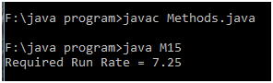

class M16 {

public static int sumOfDigits(int n) {

int sum=0, rem;

while(n!=0) {

rem = n%10;

sum += rem;

n/=10;

}

return sum;

}

public static void main(String[] arg) {

System.out.println("Sum of digits of a number = "+ sumOfDigits(47));

}

}

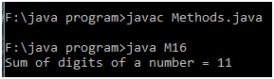

class M17 {

public static boolean andBool(boolean a, boolean b, boolean c) {

return a&&b&&c?true:false;

}

public static void main(String[] arg) {

System.out.println("Andof Boolean values = "+andBool(false,true,true));

}

}

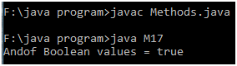

class M18 {

public static boolean largerThanOne(short n1, short n2, short n3) {

return (n1>n2)||(n1>n3)?true:false;

}

public static void main(String[] arg) {

boolean result = largerThanOne((short)234,(short)477,(short)419);

System.out.println("larger than any one no = "+result);

}

}

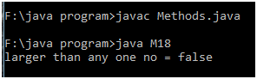

class M19 {

public static boolean ascending(short n1, short n2, short n3) {

boolean ascend = (n1<n2)&&(n2<n3)?true:false;

return ascend;

}

public static void main(String[] arg) {

boolean result = ascending((short)134,(short)398,(short)419);

System.out.println("no's are in ascending order = "+result);

}

}

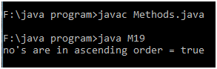

class M20 {

public static int sumOf4Digit(int n) {

int count=0, rem=0, sum=0;

while(count++ < 4) {

rem = n%10;

sum += rem;

n/=10;

}

return sum;

}

public static void main(String[] arg) {

System.out.println("Sum of 4 digits = "+ sumOf4Digit(20101));

}

}

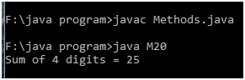

class M21 {

public static float areaOfSquare(int x1, int y1, int x2, int y2) {

float diagonal;

diagonal = (x2-x1)*(x2-x1) + (y2-y1)*(y2-y1);

return diagonal/2;

}

public static void main(String[] arg) {

System.out.println("Area of Circle = "+ areaOfSquare(2,3,8,15));

}

}

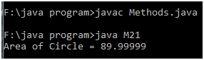

class M22 {

public static int addDigitNo(int a, int b, int c) {

int sum=0;

a = a*1000 + a*100 + a*10 + a;

b = b*1000 + b*100 + b*10 + b;

c = c*1000 + c*100 + c*10 + c;

sum = a+b+c;

return sum;

}

public static void main(String[] arg) {

System.out.println("Sum of 4 digits = "+ addDigitNo(2,4,9));

}

}

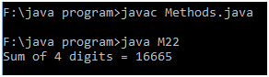

class M23 {

public static boolean div37(short n) {

return (n%3==0)||(n%7==0)?true:false;

}

public static void main(String[] arg) {

System.out.println("The given no is divisible by 3 0r 7? "+ div37((short)119));

}

}

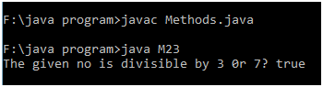

class M24 {

public static int largestNo(int n1, int n2, int n3) {

return (n1>n2)? ((n1>n3)? n1:n3) : ((n2>n3)? n2:n3);

}

public static void main(String[] arg) {

System.out.println("largest among three no is "+ largestNo(519, 218, 796));

}

}

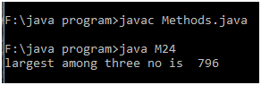

class M25 {

public static boolean isDigit(char ch) {

return (ch>='0')&&(ch<='9')?true:false;

}

public static void main(String[] arg) {

System.out.println("the given char is digit? "+ isDigit('9'));

}

}

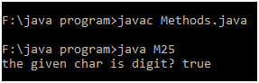

class M26 {

public static int daysInMonth(byte m) {

switch(m){

case 1: return 31;

case 2: return 28;

case 3: return 31;

case 4: return 30;

case 5: return 31;

case 6: return 30;

case 7: return 31;

case 8: return 31;

case 9: return 30;

case 10: return 31;

case 11: return 30;

case 12: return 31;

default: return m;

}

}

public static void main(String[] arg) {

System.out.println("NO of days in month = "+ daysInMonth((byte)10));

}

}

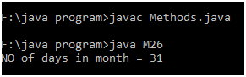

class M27 {

public static char changeCharCase(char ch) {

if((ch>='a') && (ch<='z'))

return ch -= 32;

else if((ch>='A') && (ch<='Z'))

return ch += 32;

return ch;

}

public static void main(String[] arg) {

System.out.println("change character case "+ changeCharCase('T'));

}

}

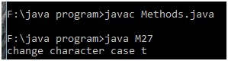

class M28 {

public static char middleChar(char a, char b, char c) {

if(((a>b) || (a>c)) && ((a<b) || (a<c)))

return a;

else if(((b>a) || (b>c)) && ((b<a) || (b<c)))

return b;

else if(((c>a) || (c>b)) && ((c<a) || (c<b)))

return c;

return 0;

}

public static void main(String[] arg) {

System.out.println("middle character "+ middleChar('7', '6', '9'));

}

}

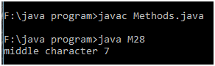

class M29 {

public static boolean sameLastDigit(int a, int b) {

a %= 10; b %= 10;

return (a==b)?true:false;

}

public static void main(String[] arg) {

System.out.println("both no's has same last digit "+ sameLastDigit(1243,258));

}

}

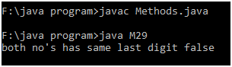

class M30 {

public static boolean addForThird(int a, int b, int c) {

if((a+b ==c) || (b+c ==a) || (c+a ==b))

return true;

else

return false;

}

public static void main(String[] arg) {

System.out.println("addition of any two no is equal to third? "+ addForThird(76, 17, 93));

}

}

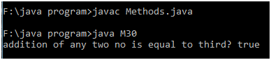

class M31 {

public static int lotteryReward(int no) {

int reward;

if((no%4==0) && (no%7==0))

return reward =20;

else if(no%7==0)

return reward =10;

else if(no%4==0)

return reward =6;

else

return reward =0;

}

public static void main(String[] arg) {

System.out.println("Reward he'll receive = "+lotteryReward(84));

}

}

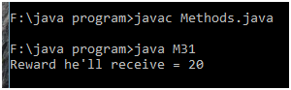

class M32 {

public static int lotteryPrize3(int a, int b, int c) {

int reward=0, count=0, no=a;

do {

if(count == 1)

no=b;

if(count == 2)

no=c;

if((no%4==0) && (no%7==0))

reward +=20;

else if(no%7==0)

reward +=10;

else if(no%4==0)

reward +=6;

else

reward +=0;

}while(count++ <2);

return reward;

}

public static void main(String[] arg) {

int result = lotteryPrize3(22,16,21);

System.out.println("Reward he'll receive for 3 lottery = "+result);

}

}

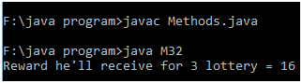

class M33 {

public static int sumLast3(int n) {

int count=0, rem=0, sum=0;

while(count++ < 3) {

rem = n%10;

sum += rem;

n/=10;

}

return sum;

}

public static void main(String[] arg) {

System.out.println("Sum of last 3 digits = "+ sumLast3(31845));

}

}

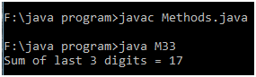

class M34 {

public static int blackJack(int n1, int n2) {

int d1, d2;

if((n1>21) && (n2>21))

return -1;

else if((n1==n2) && (n1<=21) && (n2<=21))

return -2;

else {

d1 = 21-n1;

d2 = 21-n2;

if(d1<d2)

return n1;

else

return n2;

}

}

public static void main(String[] arg) {

System.out.println("Black Jack no = "+ blackJack(18,18));

}

}

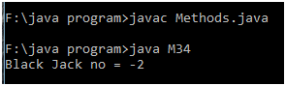

class M35 {

public static int reverseNo(int n) {

int temp=n, rev=0, rem;

while(temp!=0) {

rem = temp%10;

rev = (rev*10) + rem;

temp /= 10;

}

return rev;

}

public static void main(String[] arg) {

System.out.println("reverse of a no = "+ reverseNo(256));

}

}

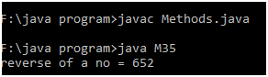

class M36 {

public static boolean perfectNum(int n) {

int i, sum=0;

for(i=1;i<=n/2;i++)

if(n%i==0)

sum +=i;

return (sum==n)?true:false;

}

public static void main(String[] arg) {

System.out.println("the given no is perfect? "+ perfectNum(28));

}

}

